Experimental Investigation into Optimal Solvent and Temperature for Maximum Energy Density of Disperse Orange 1

Jasmeen Dahak

This investigation examines the impact of solvent polarity and temperature on the cis-trans isomerization of Disperse Orange 1 (DO1) for solar thermal fuel (STF) applications. Flash photolysis was employed to determine rate constants across various solvents at different temperatures. Existing literature suggests inversion and rotation mechanisms for DO1 isomerisation, with the former showing less dependence on polarity. Our study aims to identify the dominant mechanism and assess how external factors affect STF efficiency. Results suggest a potential predominance of the inversion mechanism, with lower solvent polarity correlating to higher energy density. While higher temperatures enhance solar conversion efficiency, they decrease energy density. These findings provide insights for optimising DO1-based STFs by balancing solvent selection and temperature control.

Keywords: Photoisomerisation, Disperse Orange 1, Solar Thermal Fuel, Energy Density, Flash Photolysis

1 Introduction

Azo-dyes, such as Disperse Orange 1 (DO1), exhibit reversible photo-isomerisation, a process with promising applications in solar thermal fuels. Upon absorbing light, DO1 undergoes a molecular rearrangement, releasing energy that can be theoretically stored and converted into usable fuels. However, optimising this process requires a deeper understanding of the factors influencing the rate and efficiency of the cis-trans isomerisation in DO1 $.^{1, 2}$

**Cis isomer**

**Trans isomer**

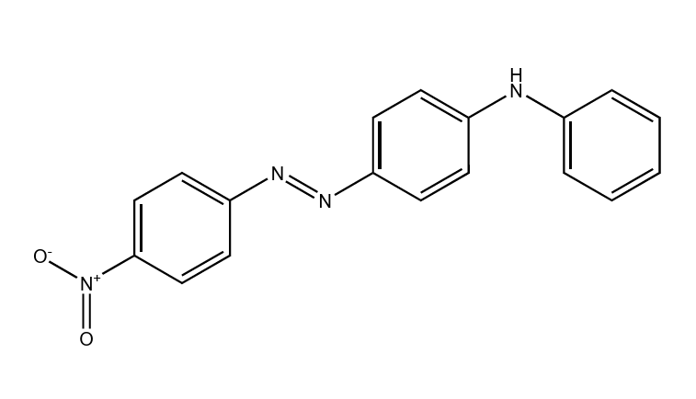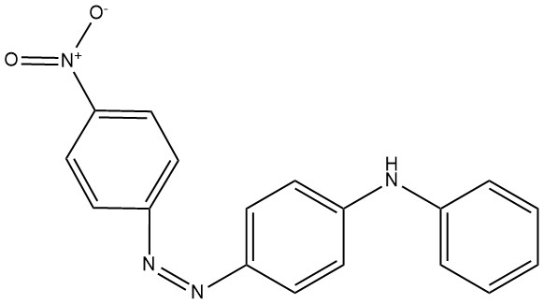

**Cis isomer Trans isomer**

hν

k



Figure 1: Cis to Trans Thermal Isomerisation Reaction

Isomerisation Mechanism of DO1

Two main mechanisms have been proposed for the reversible photoisomerisation of DO1:

* **Inversion mechanism:** This pathway proceeds through a linear transition state where the N=N double bond remains intact. Light absorption excites an electron from the ground electronic state (S₀) to a higher excited singlet state (typically S₁ or S₂). the n-π* electronic transition weakens the π-bond character of the N=N bond, allowing for inversion around the N=N axis without bond cleavage.

Figure 2: Inversion mechanism for the thermal isomerisation of DO1 following photo-conversion of trans-stable to cis-unstable isomer. $^{2}$

**Rotation mechanism:** This mechanism involves a twisted transition state with a break of the N=N π-bond. Light absorption promotes an electron to an excited state, and in this case, the electronic reconfiguration leads to a homolytic cleavage of the π-bond. The bond then rotates leading to the cis isomer formation.

Figure 3: Rotation mechanism for the thermal isomerisation of DO1 following photo-conversion of trans-stable to cis-unstable isomer. $^{2}$

This experiment investigates the impact of solvent polarity on the reaction kinetics of DO1's cis-trans isomerisation using flash photolysis. The rotation mechanism, where the N=N π-bond experiences a more significant change during the excited state, is expected to be more dependent on the solvent polarity compared to the inversion mechanism. Solvents with higher polarities can stabilise the charged species formed during the dipolar transition state for the rotation mechanism. By measuring the rate constants of the isomerisation across different solvents, we can potentially identify the dominant mechanism governing the reaction in DO1 flash photolysis and understand how solvent interactions influence the efficiency of the process. $^{1, 2, 3}$

This information will be used to identify the solvent and temperature combination that maximises the activation energy of the reaction, thereby enhancing the potential energy density obtainable from DO1 for STF applications.

**Integrated Rate Law**

This section investigates the kinetics of an isomerisation reaction. The mechanism is represented as follows.

Where the rate of reaction can be written as:

Rate= $\frac{d{[trans]}_{t}}{dt}= -\frac{d{\left[cis\right]}_{t}}{dt}=k{\left[cis\right]}_{t}$ (1)

${\left[cis\right]}_{t}$ and ${\left[trans\right]}_{t}$ are the concentration of the cis and trans isomers at time *t, k* is the first order rate constant. As the total number of molecules in the reaction is constant, we can assume at t=∞ all molecules are converted to the trans isomer, so that:

+ (2)

Subbing into equation 1:

Rate = k( ${\left[trans\right]}_{∞}- {\left[trans\right]}_{t}$ (3)

Where ${ \left[trans\right]}_{∞}$ is the concentration of the trans isomer at $t_{∞}$.

Integrating the above gives:

ln( ${\left[trans\right]}_{∞}- {\left[trans\right]}_{t})= -kt+ln⁡({\left[trans\right]}_{∞}- {\left[trans\right]}_{0})$ (4)

Where ${\left[trans\right]}_{0}$ is the concentration of trans isomers at $t_{0}$. Using Beer- Lambert’s Law:

$ln( A_{∞}- A_{t})=-kt+ln⁡(A_{∞}- A_{0})$ (5)

Where $A_{∞}$, $A_{t}$ and $A_{0}$ are absorbances at time $t_{∞}$, t and $t_{0}$ (see figure 4), a straight plot suggesting a first-order reaction (see figure 8).

Absorbance

$$A_{0}$$

Flash takes place at t=0

$$A_{∞}$$

Figure 4: Change in absorbance of trans DO1 as a function of time.

Activation energy and Arrhenius Constant can be deduced from the Arrhenius equation:

ln(k)=- $\frac{E_{a}}{R}\frac{1}{T}+\ln\left(A\right)$ (6)

Where $E_{a}$ is activation energy, R is the gas constant, A is the Arrhenius constant, and T is temperature.

Using the Eyring equation we can relate standard enthalpy of activation to $E_{a}$

$E_{a}= Δ^{‡}H^{0}+RT$ (7)

Hence there is a direct relationship between higher $E_{a}$ and higher ${ΔH}_{storage}$ and temperature.

standard entropy of activation $Δ^{‡}S^{0}$, the Gibbs free energy of activation $Δ^{‡}G^{0}$, and the quasi-equilibrium constant $K^{‡}$ with the following equations:

A= $\frac{k_{B}Te}{h}e^{\frac{Δ^{‡}S^{0}}{R}}$ (8)

Where $k_{B}$ is Boltzmann’s constant, e is Euler’s number and h is Planck’s constant.

$Δ^{‡}G^{0}=Δ^{‡}H^{0}-TΔ^{‡}S^{0}$ (9)

$Δ^{‡}H^{0}=-RTlnK^{‡}$ (10)

## Optimizing Solar Thermal Fuel Efficiency

Azobenzene dyes like DO1 offer promise for STFs due to their light-induced cis-trans isomerisation. However, maximising their utility requires a focus on three key parameters:

1. **Energy Density (ED):** This reflects the amount of energy stored per unit volume, a crucial factor for STF capacity ${. }^{4}$ We aim to maximise ED by focusing on:
   * **Enthalpy of Storage (${ΔH}_{storage}$):** Higher ${ΔH}_{storage}$ translates to energy stored per molecule.
   * **Activation Energy ($E_{a}$):** A higher $E_{a}$ allows for a larger barrier for cis-to-trans isomerisation, leading to more energy being stored (see figure 5).
2. **Half-Life of the cis Isomer:** While high ED is desirable, the stored energy needs to be maintained. Half-life (t₁/₂) represents the time for half the cis isomer population to revert to the trans form ${. }^{4}$ A longer half-life is essential for sustained energy storage. As half-life is inversely proportional to the rate constant, minimising k will maximise ${}_{\frac{1}{2}}$ . See half-life equation for first-order reaction below:

${}_{\frac{1}{2}}$ = $\frac{0.693}{k}$ (11)

1. **Solar Energy Conversion Efficiency:** This reflects how effectively absorbed solar energy is converted into the cis isomer's chemical energy ${. }^{4}$ Optimising this requires:
   * **High Isomerisation Degree:** A larger fraction of the cis isomer in the photo stationary state. (see equation 12)
   * **Efficient Photon Absorption:** Maximising the absorption of solar light by DO1 is crucial. (see below)

η (12)

These parameters are interconnected. A higher ${ΔH}_{storage }$ can lead to a higher half-life due to a lower k value for the reverse isomerisation. Finding the optimal balance is key for efficient STFs.

Figure 5: Solar thermal conversion and storage mechanism shown as energy difference of excited trans isomer, unstable-cis isomer and transition state ${. }^{4}$

2 Experimental

4-Anilino-4'-nitroazobenzene (Disperse Orange 1, DO1, 15% w/w purity) was purchased from Sigma-Aldrich and used without further purification. Solvents used were cyclohexane (≥99%, Fischer Scientific), acetone (≥99.8%, Analytical Reagent Grade, Fischer Scientific), dichloromethane (≥99.9%, ACS Reagent, Sigma-Aldrich), tetrahydrofuran (≥99.9%, ACS Grade, Sigma-Aldrich), methanol (≥99.9%, Analytical Reagent Grade, Fischer Scientific), and ethanol (≥99.8%, HPLC Grade, Fischer Scientific)

Stock solutions of DO1 were prepared in six solvents at an approximate concentration of $2 ×{10}^{-5}M$ by dissolving DO1 in the chosen solvent. The solutions were then decanted to remove undissolved salts. The exact absorbance of each solution was determined using the USB40000 UV/VIS (see x), aiming for a maximum absorbance of 0.4-0.6. Solutions were stored in amber bottles covered in aluminium foil at room temperature for no longer than 36 hours before use.

The flash photolysis setup consisted of a Metz for Nikon camera flash as the light source, a cuvette holder positioned in the beam path, and a USB digitiser (National Instruments, NI USB-6211, 16 bit, 250 kS/s) for signal acquisition. The probe light source emitted a wavelength of 470 nm. The sample solution in an optical glass cuvette was equilibrated at the desired temperature in a Grant Y28 Thermostatic Water Bath for 10 minutes before measurement. The cuvette holder and flash lamp were then covered with a lightproof cloth, and the sample was irradiated with a single flash pulse for 200 µs. The voltage across the sample was monitored over time using the digitiser until it returned to the baseline value observed before excitation.

3 Results and Discussion

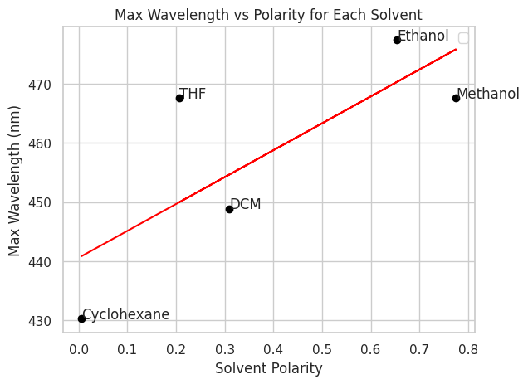Absorbance spectra reveal a bathochromic shift of approximately 45 nm for DO1 in ethanol compared to cyclohexane (see Figure 6, Table 1). This red shift suggests the formation of a more stable transition state in ethanol, which could be attributed to hydrogen bonding with DO1 or the increased polarity of the solvent environment (see figure 7) $.^{2, 5}$

Figure 7: Maximum wavelength of each solvent vs relative polarity

Figure 6: UV Vis spectra of 5 solvents used in this experiment.

was plotted against time (t) to extract the first-order rate constant (k) (see equation 5) using flash photolysis (see Figure 4). The measurements were repeated multiple times at each temperature to ensure consistency in the k values, with outliers exceeding a z-score of 2 standard deviations from the median being excluded. A higher rate of ${\left[cis\right]}_{t}$ was depleted at higher temperatures, reducing half-life. (see Figure 11)

Figure 8: change in ${\left[cis\right]}_{t}$ at 5 different temperatures as a function of time for DO1 in methanol.

Ln(k) was plotted against $\frac{1}{T}$ to extract $E_{a}$ and the Arrhenius constant (see equation 6). These values can be seen in Table 1.

Figure 9: Arrhenius plots for DO1 in the 6 solvents

Plotting log(k) against the relative polarity of the solvents (see Figure 10) revealed a moderate exponential relationship. This suggests that a rotational mechanism might be involved in the reaction; however, it may not be the sole mechanism at play.

Figure 11: First-order rate constant as a function of temperature for DO1 in methanol.

Figure 10: Plot of the log of the rate constants od DO1 against relative polarity at 300 K.

The analysis did not establish a clear correlation between activation energy ($E_{a}$) and the relative polarity of the solvents (see Table 1). However, as expected, a relationship between temperature and the rate constant was observed (see Figure 11, Equation 6).

Our findings suggest that the inversion mechanism, rather than a rotation-based one, may be dominant for DO1 due to the weak positive correlation between activation energy and solvent polarity $.^{2}$ Higher temperatures were found to reduce DO1's energy density. Increased temperatures are linked to lower activation energy and enthalpy of storage. However, higher temperature is linked to a higher proportion of trans isomers reaching the excited state by increasing thermal energy (see Equation 12) $.^{4}$ This ultimately leads to a higher degree of isomerisation translating to an improved solar conversion efficiency $.^{4}$ Depending on specific use cases, temperature needs to be balanced for either a higher solar conversion efficiency or energy density. Finally, our findings indicate that lower solvent polarity corresponds to lower k values as seen in Figure 10, consequently leading to a larger energy density for STFs.

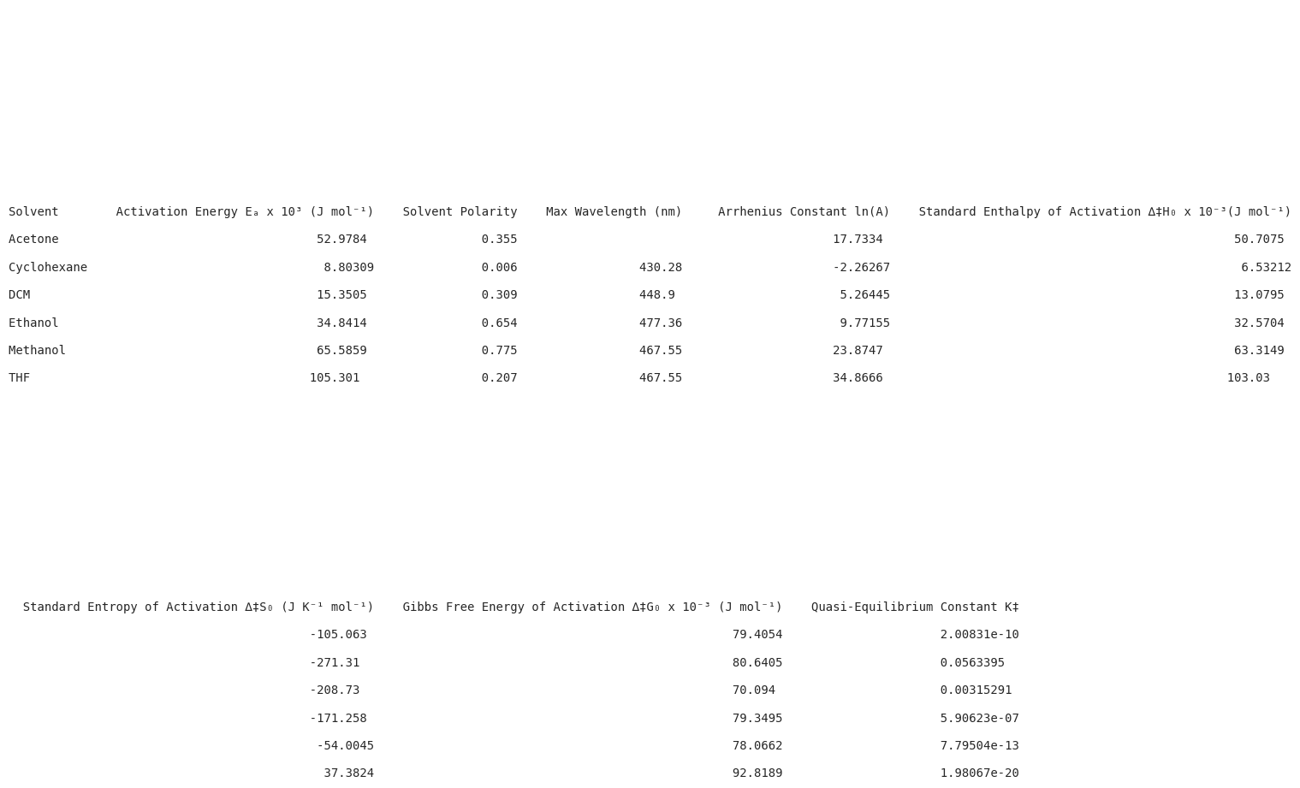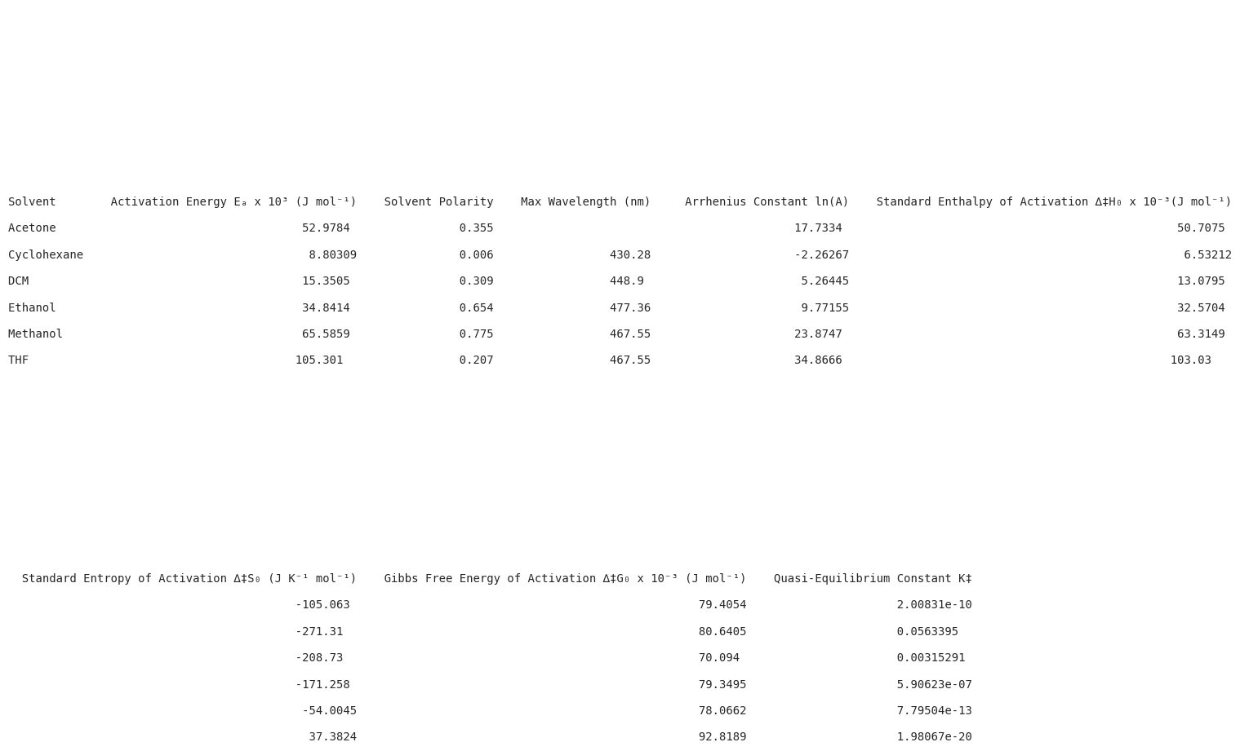

Table 1: Thermodynamic values for DO1 in 6 solvents

4 References

[1] S. Smith and F. Bou‐Abdallah, Journal of Thermodynamics & Catalysis, DOI:10.4172/2157-7544.1000181

[2] Sally R. Hair, Gregg A. Taylor, and L. Wayne Schultz

Journal of Chemical Education 1990 67 (8), 709

DOI: 10.1021/ed067p709

[3] S. Mukherjee and S. C. Bera, Journal of Photochemistry and Photobiology A: Chemistry, 1998, 113, 23–26.

[4] L. Dong, Y. Feng, L. Wang and W. Feng, Chemical Society Reviews, 2018, 47, 7339–7368

[5] Reichardt C (1998) Solvents and Solvent Effects in Organic Chemistry. VCH: Weinheim, Federal Republic of Germany, p: 418.

**Student Self-Evaluation**

Part of the feedback process for this module requires student to evaluate their own work. Self-assessment is a valuable learning tool which can help students to:

* Identify skills gaps.
* See where to focus attention for learning.
* Set realistic goals.
* Devise plans for future development.

We would like all students to reflect on their achievements for this project and complete the rubric below (this will not affect the mark you receive from the academic assessor except for the ‘Communication & Team Working’ criterium for which the student’s mark will be used by the academic).

**What you need to do:**

1. Indicate for each criterium what you feel your achievement level is.
2. This self-evaluation should be submitted as part of the same file as your report (i.e. just use this template as it is).
3. Your assessor will mark you against these same criteria (these will be visible in the Turnitin rubric).
4. Students will meet with their assessor in week 20 to discuss the feedback and reflect on any areas for future improvement.
5. Student will then be asked to write an action plan for their second project to focus on particular areas for development.

**Please note** – the detailed rubric with descriptors for each level can be found on Moodle.

|  |  |  |  |  |  |  |  |  |  |  |  |  |  |  |
| --- | --- | --- | --- | --- | --- | --- | --- | --- | --- | --- | --- | --- | --- | --- |
|  |  | **Achievement Levels** | | | | | | |  |  | | | |  |
|  |  | **0** | **1** | | **2** | **3** | **4** | **5** |  | |  |
| **Module Learning Outcomes** | **Criteria** | **Unsatisfactory** | **Poor** | | **Satisfactory** | **Good** | **Very Good** | **Exceptional** | **Assessment point** | | **%** |
| **Team working & Time Management** | Plan & devise experimental work for each laboratory session to make best use of the time available. (Includes problem solving skills to adapt plans). |  |  | |  |  | X |  | In lab (notebook & demonstrators) | | **5%** |
| Communication & team working |  |  | |  |  |  | x | Students to submit self-assessment (including a mark) with report. | | **5%** |
| **Safety & Good Lab Practice** | Identification of hazards, relevant precautions & disposal to ensure safe experimental work |  |  | |  |  |  | x | In lab (notebook & demonstrators) | | **5%** |
| Use of Good Chemistry Laboratory Practice (GCLP) |  |  | |  |  |  | x | In lab (notebook & demonstrators) | | **5%** |
| **Technical competence** | Accurately record experimental procedures & observations (lab notes) |  |  | |  |  | x |  | Notebook assessed by academics after lab finishes. | | **5%** |
| Quality experimental work |  |  | |  | x |  |  | Post-lab - Written report | | **10%** |
| **Knowledge, understanding & critical thinking** | Breadth of knowledge of the background research area of the project. |  |  | |  |  | x |  | Post-lab - Written report | | **5%** |
| Understanding of the methodologies / techniques / tools relevant to the project (e.g. synthetic routes, software, equipment, spectroscopic methods). |  |  | |  |  |  | x | Post-lab - Written report | | **5%** |
| Ability to describe relevant results |  |  | |  |  | x |  | Post-lab - Written report | | **5%** |
| **Technical writing & presentation skills** | Report is well structured. |  |  | |  |  | x |  | Post-lab - Written report | | **5%** |
| Visual elements (graphs, figures, tables): range of types of visual elements, quality and adequate presentation (labels, captions) |  |  | |  |  |  | x | Post-lab - Written report | | **5%** |
| Nomenclature, schemes, equations, figures. Style (use of technical vocabulary) |  |  | |  |  |  | x | Post-lab - Written report | | **5%** |
| Experimental data reported in journal style |  |  | |  |  | x |  | Post-lab - Written report | | **10%** |
| Degree of consistency of the formatting of the document (font size, references list, use of bold/italic, layout, spacing, etc.) |  |  | |  |  | x |  | Post-lab - Written report | | **5%** |
| Accuracy of the grammar, structure of sentences and division of text into paragraphs |  |  | |  |  |  | x | Post-lab - Written report | | **5%** |
| Use of in-text citations to support development of argument |  |  | |  |  |  | x | Post-lab - Written report | | **5%** |
| **Please indicate 3 areas in particular which you would like feedback on.** | |  | | 1. Ability to describe relevant results. 2. Breadth of knowledge of the background research area of the project 3. Visual elements | | | | | | | | |